**Assignment 6**

**Question 1**

**A Barua number is a number that consists of only zeroes and ones and has only one 1. Barua’s**

**number will start with 1. Given numbers, find out the multiplication of the numbers. Note: The**

**input may contain one decimal number and all other Barua numbers. (Assume that each number**

**is the very large and the total number of values give is also very large)**

**Input 1: 100 10 12 1000**

**Output 1: 12000000**

**Input 2: 100 121 1000000000000000**

**Output 2: 12100000000000000000**

**Input 3: 10 100 1000**

**Output 3: 1000000**

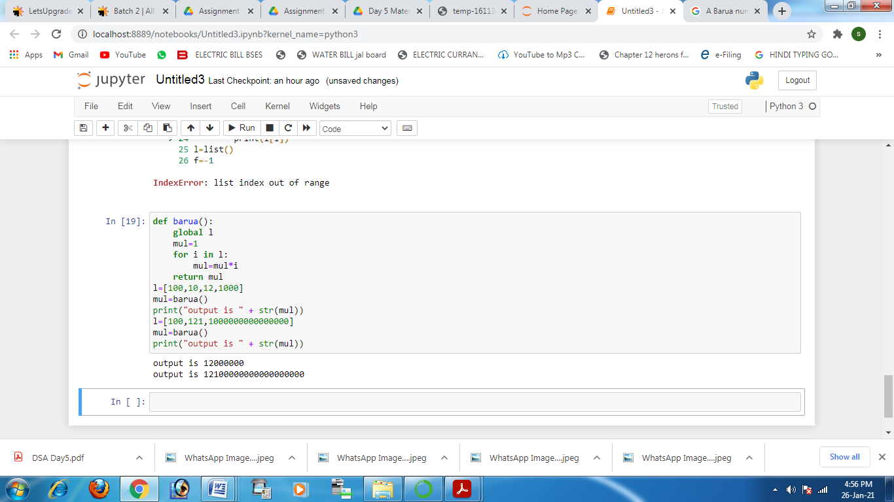

**Question 2**

**Implement push, pop and find the minimum element in a stack in O(1) time complexity.**

